Bisphenol A (BPA), a synthetic estrogen found in packaging materials, has been shown to leach into infant formula and beverages. More recently, BPA has been detected in high concentrations in cash register receipts. Random sample biomonitoring data to see if retail workers carry higher amounts of BPA concentration in their bodies than nonretail workers is as follows:

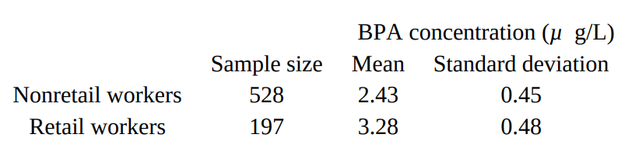

1. Calculate a 99% confidence interval for the difference in mean BPA body concentrations of nonretail and retail workers.
2. Does the confidence interval support the belief that retail workers carry higher amounts of BPA in their bodies than nonretail workers? Explain.

In a random sample of 35 NFL games, the average attendance was 68,729 with a standard deviation of 6,110, while in a random sample of 30 Big Ten Conference football games, the average attendance was 70,358 with a standard deviation of 9,139. Is there evidence that the average attendance at Big Ten Conference football games is greater than that at NFL games?